1.3 Postcard Photographers and Publishers

Bradley, Anthony (‘Tant’)

Anthony Harris Mobsby ('Tant') Bradley came to Jenolan in 1916. His grandfather, then father, had both been 'keeper' of the Yarrangobilly Caves and Bradley himself had guided parties of visitors at Yarrangobilly since the age of 10. He also assisted
in the discovery and exploration of a number of caves at Yarrangobilly, and in 1907-8 had built the major pathways of the area, many of which remain to this day (Middleton 1972, 1985a, 1985b). At Jenolan, he worked as a guide under the direction of J.C. Wiburd, and in 1932, succeeded him as chief guide and remained in that capacity until 1947. During part of that time (it is not clear exactly when or for how long) he produced postcards which were marketed at the caves kiosk.

Beattie, John Watt

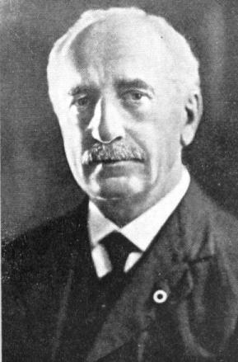

Bulmer, Howard Decimus

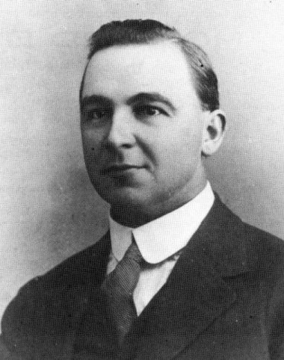

Caire, Nicholas John

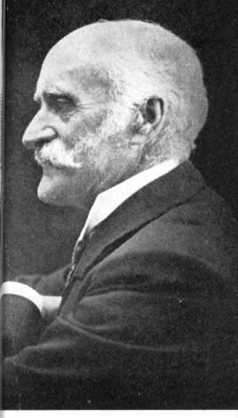

Cooke, Edward J.

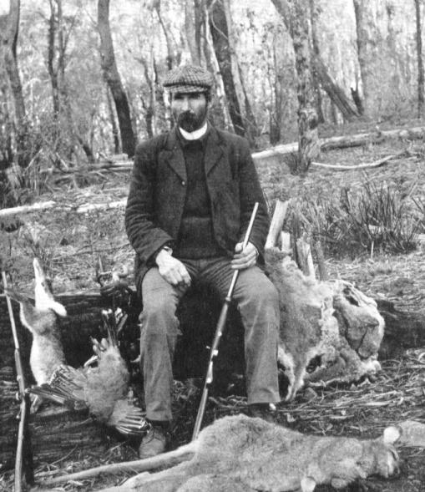

The earliest dated Jenolan postcards that we have found are those by Edward J. ("Ted") Cooke, published in 1901. Cooke was the proprietor of Kia-Ora guesthouse, built in 1905 just outside of the caves reserve, some 8 km. from the Grand Arch. He was evidently a productive photographer; he produced stereos and cabinet prints of the caves for sale to visitors; many of his photographs are used in the Trickett guides; and he used to take personal photographs of visitors to the caves and, like many personal photographs of the period, these were usually printed on postcard paper. One, dated 1906, is in the possession of the Jenolan Caves Historical and Preservation Society. So, the postcards listed in this catalogue are only one small part of his work.

Flynn, John

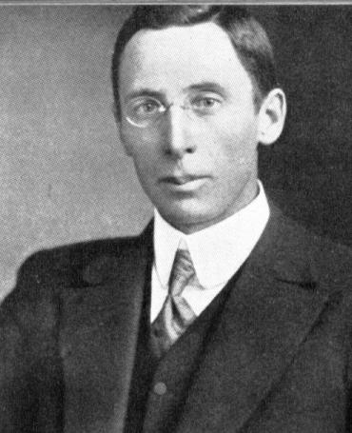

Harrington’s

Harrington’s were one of the pioneer manufacturers and warehousers of photographic equipment and supplies. This photograph of their Sydney premises indicates something of the importance of photography at about the turn of the century.

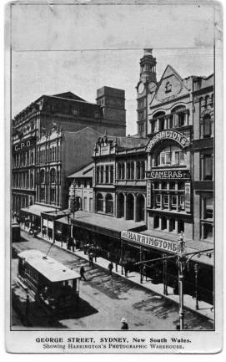
William Augustus Francis

Francis was a son of George Francis, first director of the Adelaide Botanic Gardens, and operated photographic studios from various addresses in Adelaide from 1865. He became interested in the Naracoorte area and moved there at about the turn of the century to open a studio. He is said to have remained in business until 1917, but we have seen a postcard which has a message on the back dated 7 March 1913, and stating ". . . there is no photographer in Naracoorte at present." His first known Naracoorte photographs are from 1898, and include pictures of the Reddan family and of the caves area.

Hurley, Frank

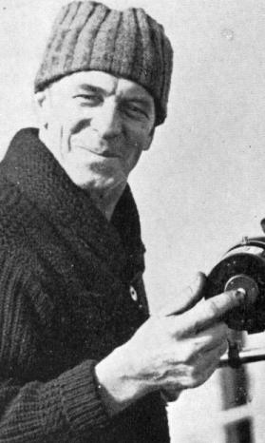

Frank Hurley (1890-1962) is probably Australia's most famous
photographer, and one of the many who demonstrated a long-standing interest in Jenolan Caves. He left home at 13 and commenced work in a steelworks while studying electrical
engineering at night. He became interested in photography as a hobby and in due course, while working at Sydney Harbour, he developed an interest in travel. His father bought him a partnership in a photographic studio at this same time, and so,
like Charles Kerry, he entered into professional photography at
the age of 17.

His first years were spent in a studio which largely concentrated upon low-priced commercial photography and postcards, but at 19, he was winning medals and awards at exhibitions. (Although the studio was named Cave and Company, and later Cave & Hurley, they do not appear to have produced postcards of caves!)

Then, in 1910, he convinced Sir Douglas Mawson that he was the
right man to be photographer to Mawson's Antarctic expedition. On
this journey, he played an important part in both exploration and the photographic duties for which he had been appointed. His still and movie photography became world famous, and remains to this day as some of the greatest of all Antarctic photography. He returned to Australia and commenced work on a movie film of the Aboriginal people around the Gulf of Carpentaria. Then in 1914, he returned to the Antarctic again, this time with Shackleton.

This expedition culminated in the ship being crushed in the pack-ice, an epic open-boat voyage to Elephant Island, then Shackleton and six others sailing on to South Georgia, and after immense difficulties, returning with a relief ship to rescue their companions, amongst whom was Hurley. On reaching London in 1916, Hurley was immediately appointed as a war photographer.

He returned to Australia at the end of the war, and travelled to Charleville to meet Sir Ross & Keith Smith on their pioneer England to Australia flight. He flew on with them, climbing out
on the wing of the plane to take movies. It is said that his first sight of Jenolan was from the air during this flight, and that on his first visit there he was accompanied by Sir Keith
Smith. His career continued with expeditions to New Guinea, the
Great Barrier Reef and again to the Antarctic with Mawson. In the
second world war, he was again appointed as a war photographer,
only because of his own insistence !

It is not clear at this stage exactly when Hurley's Jenolan postcards
were photographed or published. A mounted photograph at Jenolan
attributed to Hurley is dated 1914 (obviously incorrectly). The
earliest date we have recorded for any of the cards is 1921, so this suggests at least some of his photographs were taken between 1919 and 1921. This is confirmed by the introduction to a book of his photographs published by the N.S.W. Tourist Bureau, in which
reference is made to a visit with Sir Keith Smith in 1919.

His other cave photography includes Yarrangobilly in 1938, when making his film 'A Nation is Built' to celebrate the Sesqui-centenary ; to Jenolan on 'thirty separate expeditions' to obtain
photographs for his book 'The Blue Mountains and Jenolan Caves' ;
and then in 1961 to Weebubbie Cave on the Nullarbor Plain.

His photographs of Jenolan are characterised by their clarity and even lighting. Hurley certainly provided some of the finest photographs of J.C. Wiburd in his role as guide, although few of these appear on postcards.

None of Hurley's postcards of Jenolan that we have seen bear his
name, but they can be (and in compiling this list have been)
identified by comparison with books and leaflets which use the same photographs. (Cato, 1979 : 137-43 ; Legg & Hurley, 1966 ; Bickel, 1980 ; Anon. 1981 ; Millar 1984)

Fullwood, Albert Henry

Albert Henry Fullwood (1863-1930) was born in Great Britain and migrated to Australia in 1881. He was a staff illustrator for the Picturesque Atlas of Australasia, and did illustrations for various magazines. He was recognised as a major artist, and played a leading role in the foundation of the N.S.W. Society of Artists. He returned to Britain in about 1900, producing paintings for the Tuck postcards during this period. He was later commissioned as an official war artist by the Australian War Memorial, and returned to Australia in 1920. It is not clear whether he did any Jenolan paintings on site, although it is certain that he did not draw the Jenolan illustrations in the Picturesque Atlas. (Cook 1986, pp. 111-2)

Johann Herman Bernhardt (Benny) Kannenberg

Kannenberg was the first process block maker in Mount Gambier
and produced illustrations for the Mt. Gambier 'Borner Watch' for
many years. He also operated his own photographic studio, and
published a number of booklets and other souvenirs (including
postcards). Many of the large framed views of the Blue Lake,
commonly seen even today, are his work. He produced postcards of
Naracoorte, Mt. Gambier and Tantanoola, few of which bear his
name, but can be recognised by comparison with his souvenir books
and by extrapolation, from his distinctive backs and printing
style. Many of the postcards have a deeply impressed title in
deep blue or purple. He worked in the region for some 60 years,
dying on 29 August, 1962 (Border Watch, 30 Aug. 1962).

Kerry, Charles

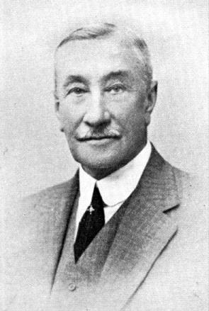

Charles Kerry must be considered one of Australia's great pioneer photographers. He entered the photographic business in 1875 at the age of 17 years, and soon established
a flourishing enterprise. By 1890, he was employing a large staff, and so many of the photographs taken by his staff were published as Kerry photos. However, it is likely that Kerry himself took the cave pictures; he was a keen outdoorsman, and among other activities, took a great interest in cave exploration. He was friendly with Oliver Trickett (q.v.), who was employed as a cave explorer and surveyor by the government of the day, and accompanied him on various occasions. The only cave cards published by Kerry that appear to have not been photographed by him are those which are, either on the card or in some other publication, acknowledged to Trickett.

In the case of Yarrangobilly, he is generally credited with having played a part in the exploration of the caves, but the claim that he discovered the Jersey Cave cannot be substantiated (see under Yarrangobilly below). His other interests included skiing and mineralogy. He was one of the pioneers of skiing as a sport in Australia and was the first president of the Alpine Club. This interest is also reflected in his photographs, including the first pictures of snow caves in Australia.

His earliest well-known cave photographs are the illustrations in a book by Samuel Cook, The Jenolan Caves: An Excursion in Australian Wonderland, published in
London in 1889. This was an early fore-runner of the 'coffee-table book' tradition, and the first to be illustrated throughout with photographs of caves! The earliest of his
cave postcards that we have seen is dated 1903, although he probably commenced publication before this date. His first postcards are based upon earlier Jenolan photographs. Thus, cards which we number below as 2.2, 3.8, 3.11, 3.12,
4.1, 7.1, 7.5, 7.8, 9.8 and 9.11 can all be identified as being printed from the same negatives as a series of prints that were apparently produced during the period 1892-1897.

These were followed by many later series, and at least in some cases, Kerry was able to photograph caves very soon after their first discovery and before any paths had been established. In some cases, it is very likely that his photographs were taken prior to the formal announcement of the discovery. The N.S.W. Tourist Bureau also formally commissioned at least some of his photographs. He had a sale kiosk at Jenolan (see 10.1 below) and it is said that he used to take personal photographs of visitors to the caves, although we have no real evidence of this.

He retired in 1913, handing the business over to his nephew, and entered the mining industry. Unfortunately, his successor lacked Kerry's skill and enterprise and the business soon collapsed. (Anon. 1898; Burke 1952; Cato 1979: 65-69; Millar 1981)

A small souvenir booklet of Jenolan published by Kerry (undated) lists the various numbered series of Jenolan cards, and gives the prices as being one shilling for each set of collotype cards and threepence each for real photo cards. It also lists the various numbered series and the number of cards in each.

By courtesy of David Millar and the Mitchell Library, we have also had access to a copy of Kerry's 1908 Trade catalogue of his Collotype Cards. This offered sets of 12 for seven pence and also refers to some series as 'penny hand-coloured cards'.

Cards of Kosciusko are priced at two shillings per dozen, or twelve shillings per gross. Cards of Yarrangobilly are one shilling per packet of twelve or 7/6 per gross. Hand-coloured cards are listed elsewhere at six shillings per gross. Finally, there is a list of 216 towns or localities from which cards could be printed to order. This list includes the cave areas of Abercrombie, Jenolan and Yarrangobilly. The printed-to-order cards would have been what are now known as the Real Photo cards.

We have used the information from this list to supplement our work wherever it proved useful to do so. Any such information is referenced to Kerry (1908), and in such cases, we may not have independent confirmation by seeing the actual cards.

Kitch, George B.D.

Kitch established his studio and stationer's shop in Katoomba in 1886. He was Mayor of that city, and later President of the Katoomba and Leura Tourist Association. (Burke, in Stanbury & Bushell 1985: 97, 102 ; also photograph in Kay 1985, p. 17)

McCarthy, J.J.

McCarthy was at one time a partner in the studio of McCarthy & Stephenson of Sydney, but later moved to Jenolan, apparently as resident photographer. As well as his postcards, we have seen mounted prints of tour parties with the rubber-stamped imprint "By special arrangement with the N.S.W. Govt. / J.J. McCarthy, Photographer / Jenolan
Caves, N.S.W."

Macdougall, James Henry Arthur

1880-1944

Rose Stereograph co.

George Rose (1861-1942) must, by any count , be considered the most prolific stereographic photographer of Australia, but also published an immense number of postcards. Initially working in the footwear industry, he soon made his hobby of photography into a full-time occupation, and established the Rose Stereograph Co. in 1880.

He travelled widely, sending back photographs from all over the world to be printed as stereo views. In the course of his travels, he became an expert mountaineer, climbing in Norway, Switzerland and New Zealand. He also carried his cameras extensively throughout the Australian bush, being an ardent
Bushwalker.

It is said that he commenced postcard publication in 1908, but the earliest dated card of which we are aware is one from 1913.

During the depression years, he provided cameras to a number of young people and sent them to photograph Australian country towns.

He handed over the business management of the company in due
course to his son Walter (who died shortly before his father) and on Walter's death the company passed to two former employees, Gilbert and Cutts, and it continues to this day. (Blum 1978; Cook 1986, p. 148)

Apart from an immense number of stereos, The Rose Stereograph Co. produced an immense number of real photo postcards, each with a number and each on a variety of printing papers with distinctive backs. The Kodak series of backs were also used. The Rose backs of which we are aware are tabulated below. In many cases, minor variants on each of these can be found, such as different coloured inks (black, blue, grey or brown) or slightly different typefaces. We have not attempted to deal with all of these, but have simply developed a simple classification of major patterns.

A large collection of Rose's cards, glass negatives and the original company stock-book are in the LaTrobe Library, Melbourne. Any cards recorded here only from the negative collection are indicated with an asterisk (*).

The New South Wales Bookstall Company 1897

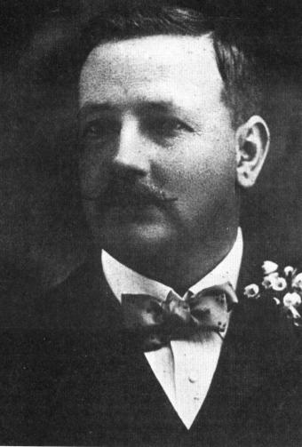

Alfred Cecil Rowlandson

The company, established in 1897, owned all the bookstalls on Sydney's railway stations. Alfred Cecil Rowlandson became manager at the age of 22 years, and launched an unpredecented publishing enterprise. The Art Series postcards, some which depicted Jenolan and are listed below were really only a very minor part of his initiative. More importantly, he conceived the idea (long before Penguins!) of selling one shilling paperback versions of Australian novels. Starting with Steele Rudd's
'Sandy's Selection' in 1904, he eventually sold some five million
copies of 200 Australian novels. (Anon., 1974 ; Cook 1986, pp.
143-5; Mills 1991)

A. J. SHEARSBY

Shearsby, Alfred James

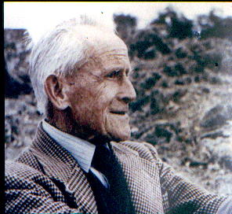

A.J. Shearsby was a complex and interesting figure, and deserves to be better known. He initially arrived in Yass as a bank clerk, but resigned his position so that he might stay in Yass to pursue his enthusiasm for the local geology. He remained throughout his life. He achieved a high reputation for the quality of his observation and analysis - a well-known exposure of fossils South of Yass commemorates this interest, having been named "Shearsby's Wallpaper".

As secretary of the local Chamber of Commerce, he tried to foster tourism in the district. As well as his photographic skill, demonstrated in these postcards, he was a landscape painter of some talent, and also wrote extensively on the district. In particular, he produced the

1921 Yass Centenary souvenir and Guidebook.

Phillips, Harry

Another great photographer whose works appear on postcards was Harry Phillips of Katoomba. Phillips was born at Ballarat, Victoria in 1873 as the son of a Cornish mining family. He trained as a printer, and travelled about in search of satisfactory work, moving to Sydney with his wife and only child
in 1905.

Then, in 1908, he injured his hand in a press and was unable to continue work. He went to the Blue Mountains for a holiday, camping in a tent at Katoomba. After three weeks, he returned to Sydney, wound up his affairs, bought his first camera and returned to Katoomba.

He spent many hours at cliff-top lookouts, and soon commenced taking photographs of visitors. Then he rented a shop where he was able to sell photos of local scenery, do some portraiture, and sell drinks and confectionery. In due course, he moved to a better shop, then progressively took over neighbouring premises.

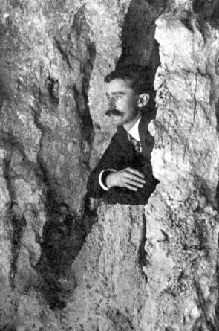

In1912, he bought a printing press, and commenced publication of the view albums which were his major output over the years to come. In all, he published over 60 books of photographs, including a number of Jenolan Caves.

Not content with photography, he became an ardent advocate for the Blue Mountains. He pressed, often with little result, for a great number of
steps which might be taken to make the Mountains more accessible and attractive to people. This enthusiasm led him to sell his books cheaply, many of them in tens of thousands, and
often to give away prints rather than sell them. We hasten to add that Phillip's work is no longer given away, or even available cheaply!

In 1922, he left Katoomba, having made little money and feeling deeply disappointed. He continued his business from Willoughby -
a Sydney suburb - and was more commercially successful. However, he maintained his interest in the mountains, often spending time travelling and photographing with his friends.

Then in the early 1940's, his health deteriorated and he returned to Katoomba to recuperate. His wife sold his stock and equipment to Murray views (of Gympie, Queeensland) and although they published various of his negatives, they eventually discarded them in 1972. Meanwhile, Phillips' health had deteriorated further and he died in 1944. (Kay 1980, 1985)

Perhaps regrettably, his postcards do not do justice to the quality and variety of his photography as evidenced by his prints and albums.

Sands And Mcdougall

The firm of Sands and McDougall can trace its origins to1851, when James Williams established a printing, paper- ruling and bookbinding business. The firm changed hands on several ccasions and became Sands and McDougall in 1862. Williams moved toAdelaide in1866, and again was bought out by Sands & McDougall in 1882. The company has continued ever since, with interests in printing, binding, publishing, associated manufacturing and retailing, and having a complex corporate history. They first applied for copyright of a postcard design in 1906, and produced over 370 postcards. (Watts 1984; Cook 1986, p. 149)

Stephen Spurling III

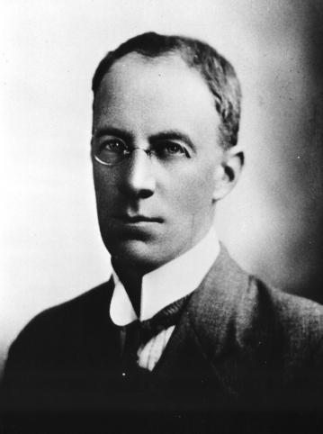
(From collection of the Queen Victoria Museum and Art Gallery, Launceston.)

James & Donald Taylor

James Taylor was a prominent South Australian artist and photographer, who worked in Gawler, Port Augusta and Quorn (Davies & Stanbury 1985: 238) and who developed the use of the
collotype process in Australia. His son Donald then established an Adelaide-based printing company in 1903 which was responsible for a very large number of fine collotype cards. (Cook 1986: 151-2)

Of the cards listed here, some are recognisable as Taylor cards both by their quality and by the distinctive coat of arms on the back. However, there is no printer imprint, and as Donald Taylor's cards of that date were an atypical shape, it is possible that they were printed by the father, whose imprint actually appears on others.

Trickett, Oliver

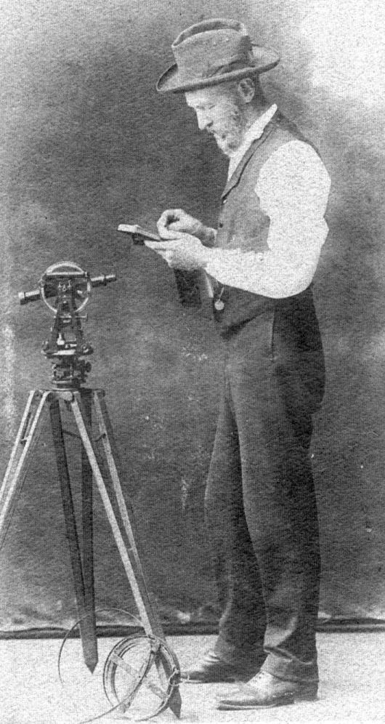
Oliver Trickett was born in Yorkshire on 29 May 1847 and his father, a minister in
Suffolk, was an admirer of Oliver Cromwell, and so named his son after him. The family came to Australia in about 1860 and settled in East Melbourne. Oliver was educated at Scotch College and, after passing the civil service examinations, joined the Victorian Department of Mines as a draftsman. He was licensed as a surveyor on 12 October 1868, and a mining surveyor on 25 November 1870.

He was an active member of the Civil Service Rowing Club, stroking the crew that won the 1868 Melbourne Regatta and was a member of the winning crew on the first eight-oared races in Australia - the Footscray Challenge Plate in 1875 and the Barwon Challenge Plate in 1876.

He was licensed as a surveyor by the N.S.W. Department of Lands on 27 June 1876, and left for Sydney on the mail steamer "Queensland" on 2 August of that year. The vessel collided with another ship and sank off Wilson's Promontory. All passengers and crew were rescued by the other vessel and returned to Melbourne. Trickett eventually reached Sydney and started work as a draftsman with the N.S.W. Department of Lands on 10 August 1876. He was gazetted as a mining surveyor for N.S.W. on 20 February 1880 and joined the Mines Department on 16 June 1892.
His work included the preparation of a mineral map of N.S.W. and a register of mining localities. (It is completely unknown at this stage as to when he first became acquainted with Charles Kerry, but in view of Kerry's passion for minerals and mining, it may well have been at this very early stage.) In 1896 he was placed in charge of limestone caves, thus beginning his long and extremely fruitful connection with N.S.W. caves.

Trickett visited, surveyed, photographed, modelled and wrote about these caves throughout the remainder of his professional career, only retiring in 1919. He made a
singular contribution to the survey, development and promotion of the caves.

Trickett's lasting memorials are his various guidebooks to cave areas (Jenolan 1899, 1905, 1915, 1922 ; Yarrangobilly 1905, 1917 ; Wombeyan 1906; Abercrombie 1906;
Bungonia 1906 and Wellington 1906), his reports and cave maps (mainly in the annual reports of the Department of Mines (1896-1919) and in Carne & Jones 'The Limestone Deposits of N.S.W.') ; his remarkably detailed three-dimensional models of mines and caves, only a few of which survive ; and the postcards recorded here.

Although his friendship with Kerry is clear, the exact nature of their business association is not. A number of the Kerry postcards show views that are credited to Trickett as the photographer in his guidebooks. Other photographs in the guidebooks are acknowledged to various photographers, including Kerry, so it appears that any attribution to Trickett is deliberate. Where possible, we have noted these below. In
addition photographs taken from identical camera positions are respectively attributed to Kerry and Trickett (see Jenolan 31.32 below) ; and Kerry also published his series
102, depicting the Yarrangobilly Caves, with the initials 'O.T.' as identification; this may well be an attempt to avoid the restrictions on government officers earning
additional income, which might have prevented Trickett publishing in his own name. (Middleton 1991)

Raphael Tuck and Sons. Ltd.
Raphael Tuck was born (then known as Tuch) in Poland in 1821, and after various moves, came to Britain in 1865. He opened a small shop, dealing in furniture and picture-framing, and gradually expanding into printing and publishing.

By 1873, the family adopted the name Tuck, and Raphael was joined in business by three of his sons. In 1880, they ran a Christmas Card design competition with a prize of 500 guineas. Over 5,000 entries
poured in, were exhibited at the Dudley Galleries, and the resultant reputation of the company placed them amongst the greatest card publishers of all time.

The company also developed its famous trademark of easel, palette
and brushes in that year, then in 1893, was rewarded with the Royal warrant of appointment as stationers to Buckingham Palace. By the time the Oilette series of postcards - a new high
in printing quality - were introduced in 1903, the company had over 10,000 different postcard designs already in print.They continued for many years as innovators in postcard production, and
in various ways (competitions, newsletters, etc.) did a great deal to foster the collecting of cards. (Byatt, 1978 : 287-301)

Amongst their production were a number of Australian and New
Zealand views, many of which were painted by the artist A.H. Fullwood. (Cook 1986, pp.156-7) The relevant series to this listing depicts views of Jenolan, each of which show well-known features together with two or more visitors. A certain artistic
licence has been used, and the features shown (with the possible exception of the Devil's Coach-house) are often enlarged in proportion to the visitors.

